PIZZA SALES SQL QUERIES
- KPI’s

- Total Revenue:
SELECT SUM(total_price) AS Total_Revenue FROM pizza_sales
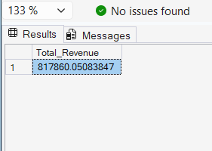
- Average Order Value:
SELECT SUM(total_price) / COUNT(DISTINCT order_id) AS Avg_Order_Value FROM pizza_sales
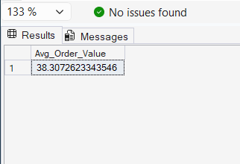
- Total Pizza Sales:
SELECT SUM(quantity) AS Total_Pizza_Sales FROM pizza_sales
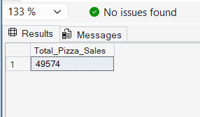
- Total Orders:
SELECT COUNT(DISTINCT order_id) AS Total_Orders FROM pizza_sales
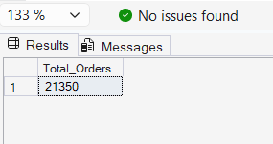
- Average Pizzas per Order:
SELECT CAST(CAST(SUM(quantity) AS DECIMAL(10,2)) /
CAST(COUNT(DISTINCT order_id) AS DECIMAL(10,2)) AS DECIMAL(10,2)) AS Avg_Pizzas_per_Order FROM pizza_sales
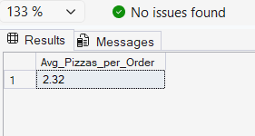

- Daily Trend for Total Orders
SELECT DATENAME(DW, order_date) AS Order_Day, COUNT(DISTINCT order_id) AS Total_Orders
FROM pizza_sales
GROUP BY DATENAME(DW, order_date)
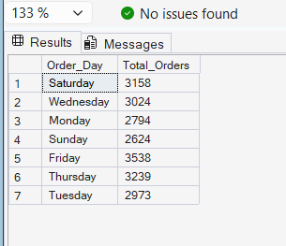
- Hourly Trend for Orders
SELECT DATEPART(HOUR, order_time) AS Orders_Hours, COUNT(DISTINCT order_id) AS Total_Orders
FROM pizza_sales
GROUP BY DATEPART(HOUR, order_time)
ORDER BY DATEPART(HOUR, order_time)
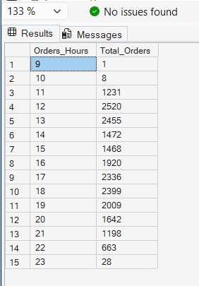
- Percentage of Sales by Pizza Category

SELECT pizza_category, SUM(total_price) AS Total_Sales, sum(total_price) * 100 / (SELECT SUM(total_price) FROM pizza_sales) AS PCT
FROM pizza_sales
GROUP BY pizza_category

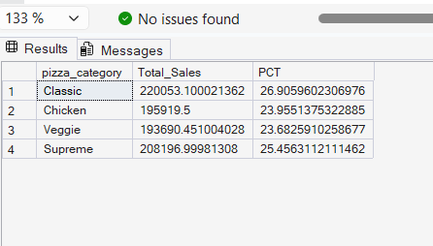

- Percentage of Sales by Pizza Size

SELECT pizza_size, SUM(total_price) AS Total_Sales, CAST(SUM(total_price) * 100 /
(SELECT SUM(total_price) FROM pizza_sales) AS DECIMAL(10,2)) AS PCT
FROM pizza_sales
GROUP BY pizza_size
ORDER BY PCT DESC
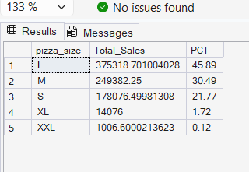

- Total Pizzas Sold by Pizza Category

SELECT pizza_category, SUM(quantity) AS Total_Pizzas_Sold
FROM pizza_sales
GROUP BY pizza_category
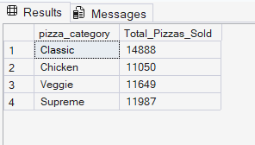
- Top 5 Best Sellers by Total Pizzas Sold

SELECT Top 5 pizza_name, SUM(quantity) AS Total_Pizzas_Sold
FROM pizza_sales
GROUP BY pizza_name
ORDER BY Total_Pizzas_Sold
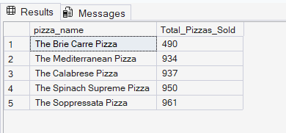

- Bottom 5 Best Sellers by Total Pizzas Sold

SELECT Top 5 pizza_name, SUM(quantity) AS Total_Pizzas_Sold
FROM pizza_sales
GROUP BY pizza_name
ORDER BY Total_Pizzas_Sold ASC
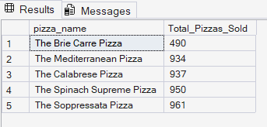

NOTE
If you want to apply the Month, Quarter, Week filters to the above queries you can use WHERE clause. Follow some of below examples

SELECT DATENAME(DW, order_date) AS order_day, COUNT(DISTINCT order_id) AS total_orders
FROM pizza_sales
WHERE MONTH(order_date) = 1
GROUP BY DATENAME(DW, order_date)

*Here MONTH(order_date) = 1 indicates that the output is for the month of January. MONTH(order_date) = 4 indicates output for Month of April.

SELECT DATENAME(DW, order_date) AS order_day, COUNT(DISTINCT order_id) AS total_orders
FROM pizza_sales
WHERE DATEPART(QUARTER, order_date) = 1
GROUP BY DATENAME(DW, order_date)

*Here DATEPART(QUARTER, order_date) = 1 indicates that the output is for the Quarter 1. MONTH(order_date) = 3 indicates output for Quarter 3.

